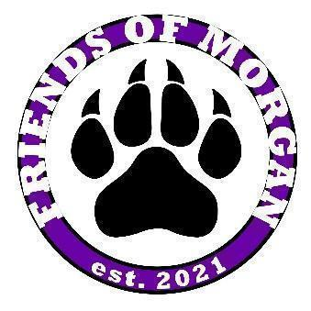
Friends of Morgan 2021-2022
Open Board Meeting Minutes
February 23, 2022 at 8:00 am

- Meeting Called to Order at 8:05 am, Held at Morgan Elementary Library LGI room
- Roll Call: Quorum Reached
  - Introduction of Board Members:
    - President – Dawn Steph (absent)
    - Vice President – Lindsey Duke
    - Vice President of Programs – Courtney Abbott
    - Treasurer – Christy Reed (absent)
    - Secretary – Jenn Bayes
- Meeting Minutes
  - Motion to approve meeting minutes from December 15, January 14 and January 26 made by Jenn Bayes, seconded by Courntey Abbott and approved
- President Update
  - Mascot Naming Contest Winners
    - Violet - Juliet Francois
    - Fletch - Brooke Blazar and Owen Firor
- VP Update
  - Yearbook - uploading images
  - Spring Events
    - Movie Night - March 4 - open to public
      - Tickets/Pizza Orders
      - Movie: Encanto
      - Silent auction: Live Monday and ends 10pm Friday
    - Father/Daughter Dance - April 1 (Theme: Dynamic Duos)
    - Mother/Son Baseball Game - April 9 at12pm
- VP of Programs Update
  - FOM Spirit Shop - last order has been closed and submitted
- Treasurer Updates
  - Budget - $34,000
  - Sponsorships
    - Community - $12,500
    - Movie Night - $3,150
    - Family Paw - $6,000
- Secretary Updates
  - N/A
- New Business
- Adjourned at 8:32 am, Motion to close by Courtney Abbott, seconded by Jenn Bayes

FOM Purchases
- Field trip for each grade
- Aprons for Art Room
- Mascots
- Rain coats and Umbrellas
- Teacher Luncheons
- Staff lunch totes and keychains
- Paws for gym floor
- Names on classroom and office doors
- Friday shirts for staff

Upcoming Dates
- February 25 - 2nd Grade Field Trip to Blessington Farms
- March 2 - Read Across America/Dr. Seuss Day
- March 4 - Movie Night (Spring Fundraiser)
- March 7 - 11 School Diagnosticians’ Week
- March 10 - 3rd Grade Field Trip to Minute Maid
- March 10 - 4th Grade Field Trip to Fort Bend Museum
- March 11 - Early Release
- March 14 - 18 Spring Break
- March 23 - FOM Open Board Meeting
- April 1 - Father Daughter Dance
- April 3 - 9 School Librarians’ Week
- April 8 - Field Day
- April 15 - No School
- April 18 - No School
- April 18 - 22 Volunteers in Public Schools Weeks
- April 22 - Kinder Field Trip to Downtown Aquarium
- April 25 - 29 Administrative Professionals’ Week
- April 27 - FOM Open Board Meeting
- May 1 - School Principal Appreciation Day
- May 2 - 6 Teacher and Staff Appreciation Week
- May 4 - Teacher Luncheon
- May 9 - 12 School Nurses’ Week
- May 11 Public School Paraprofessional Day
- May 25 - FOM Open Board Meeting
- May 26 - Last Day of School!

