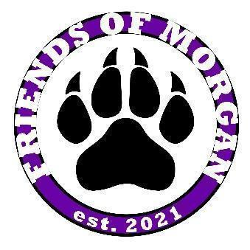
Friends of Morgan 2020-2021
Executive Board Meeting Minutes
March 21, 2022 at 5:30 pm

- Meeting Called to Order at 5:35 pm, Held via Zoom
  - Roll Call: Quorum Reached
  - Attendees:
    - President – Dawn Steph
    - Vice President – Lindsey Duke
    - Vice President of Programs – Courtney Abbott
    - Treasurer – Christy Reed
    - Secretary – Jenn Bayes
- President Update
  - Board Nominations and Election Discussion - jot form ballots to go out week of April 4th and close April 10th
    - President
    - Vice President (President Elect)
    - VP of Programs
    - VP of Fundraising
    - VP of Spirit
    - Treasurer
    - Secretary
    - Chairs:
      - Hospitality, Teacher Appreciation, Yearbook, Mother/son event, Father/Daughter event, Movie Night, Gala, Work Room
  - LCISD Instructional Calendar
  - End of the Year Party
- VP Update
  - Volunteers of the Month
    - January - Tamera Wagner & Mandi McDougal
    - February - Marisa Frazier
    - March - Amber Withum
  - Fundraising Ideas
    - Popcorn for snacks
    - Birthday Marquee
    - School Store
  - Spring Events
    - Movie Night - March 4
    - Father/Daughter Dance - April 1 (Theme: Dynamic Duos)
      - Free event and pizza
      - Need to have RSVP estimate to order pizza for
    - Mother/Son Baseball Game - April 9 at 12pm
      - Free event and concession ticket for each son
      - Need to have an RSVP estimate to provide high school
- VP of Programs Update
  - FOM Shop Update
    - previous orders should go out this week
    - need to know 2022-2023 theme to work on next year's designs
- Treasurer Updates
  - Budget update
    - Missing check from Marco's pizza for movie night spirit night proceeds
  - Movie Night - just shy of $13,000
  - Sponsorships
    - Community - $12,500
    - Movie Night - $3,150
    - Family Paw - $6,000
- Secretary Updates
  - Directory for next year
- New Business
- Meeting adjourned at 6:47pm

FOM Purchases
- Field trip for each grade
- Aprons for Art Room
- Mascots
- Rain coats and Umbrellas
- Teacher Luncheons
- Staff lunch totes and keychains
- Paws for gym floor
- Names on classroom and office doors
- Friday shirts for staff

Upcoming Dates
- March 23 - FOM Open Board Meeting
- April 1 - Father Daughter Dance
- April 3 - 9 School Librarians’ Week
- April 15 - No School
- April 18 - No School
- April 18 - 22 Volunteers in Public Schools Weeks
- April 22 - Kinder Field Trip to Downtown Aquarium
- April 25 - 29 Administrative Professionals’ Week
- April 27 - FOM Open Board Meeting
- May 1 - School Principal Appreciation Day
- May 2 - 6 Teacher Appreciation Week
- May 4 - Teacher Luncheon
- May 9 - 12 School Nurses’ Week
- May 11 Public School Paraprofessional Day
- May 25 - FOM Open Board Meeting
- May 26 - Last Day of School!

